1.Extract the Tools
Unzip RKDevTool_v3.19_for_window.rar.
- Install Drivers
First, install the drivers included in DriverAssitant_v5.12.zip.
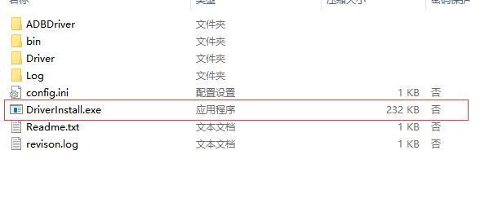
- Open the Tool
After installation, launch RKDevTool.exe.
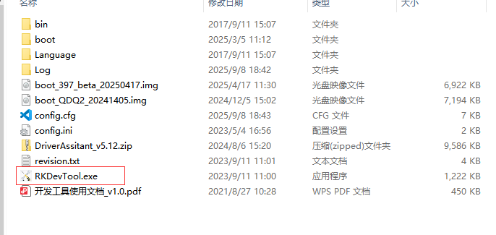

- Click to upgrade the firmware button, connect the USB to TYPE-C, and connect the computer and motherboard ( The 升级固件 is means the firmware button below )
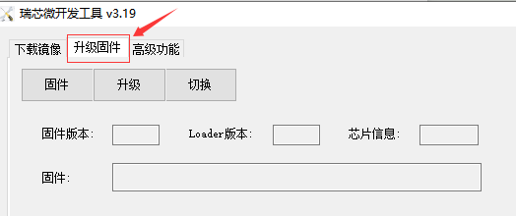
5.
Connect the Printer

Use a “USB to Type-C cable” to connect the computer and the Q2 mainboard.
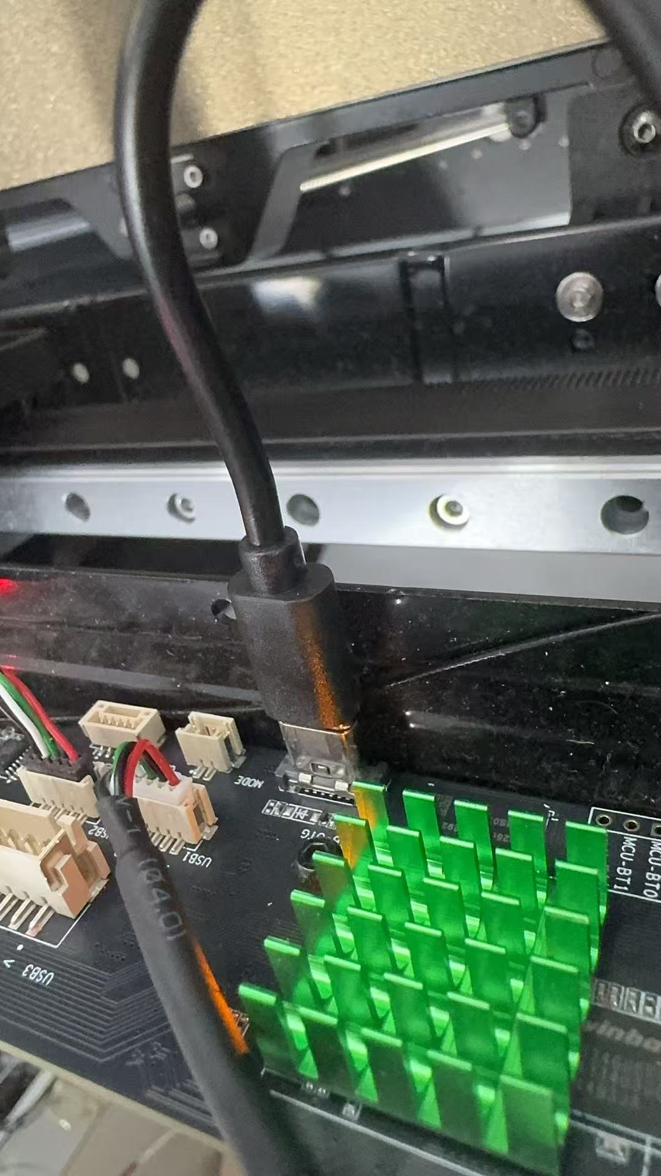
6.Unzip the firmware package, for example:

KLP_IMG_QD_Q2_V1.0.0_20250319_Release.zip

Inside, you’ll find an image file such as:
KLP_IMG_QD_Q2_V1.0.1_20250505_Release.img. See the photo below.
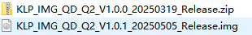
Choose the img--- KLP_IMG_QD_Q2_V1.0.1_20250505_Release.img, See the photo below.
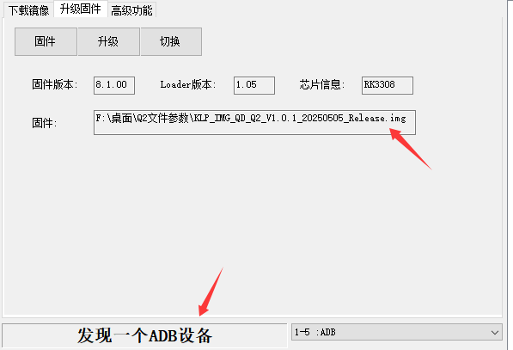
When the connection is successful, the tool will display “ADB device detected.”

- Click Switch button, the 切换 is the switch button. See the photo below.
After click switch button, a loader device will be found on the button.
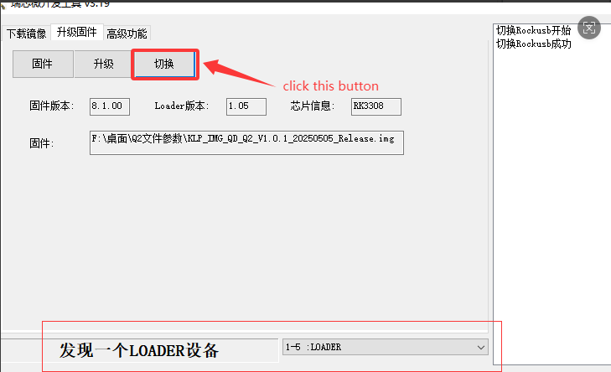
At this time, you can click Upgrade. When the progress bar reaches 100, it means the re-flash is successful. Final step, please use the offline update package to update the firmware.

